
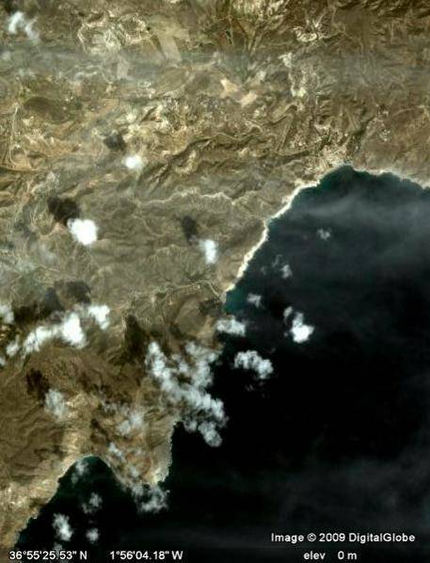
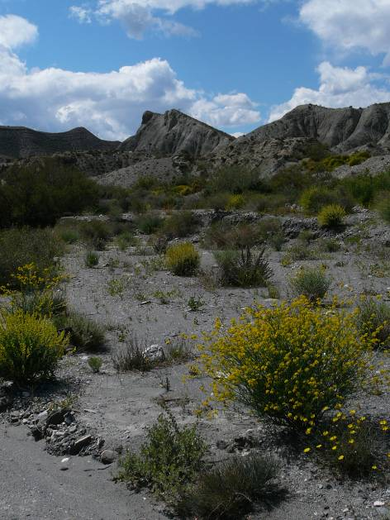


Postdoctoral fellow in Spatial Ecology: spatial scaling of biodiversity

We are looking for a postdoctoral research fellow to develop and apply spatial ecological and conservation biology theory. The work would explore spatial aspects of population dynamics, species diversity and conservation practice, focusing on the development of approaches that examine and model processes acting at different spatial scales. The work would involve a mixture of theory development and dataset analyses, to address in particular the application of multi-scale ecological ideas to developing effective conservation strategies for Europe. Fluency in computer programming and spatial data analysis (e.g. GIS and spatial statistics) would be key for this post; good communication and leadership skills would be extremely useful. A keen interest in conservation biology theory and practice would also be extremely valuable. The post is part of the EU-FP7 SCALES (“Securing Conservation of biodiversity across Administrative Levels and spatial and temporal Ecological Scales”) project, and so would involve collaborations with an interdisciplinary team of scientists from across Europe (and beyond).

Initial appointment would be for a period of 24 months, with potential extension for an additional 6 months or more (depending on exchange rates).

University Grade 7 (£28,290 - £33,780)

For informal enquiries, please contact:
Prof William Kunin, w.e.kunin@leeds.ac.uk tel: +44 (0)113 343 2857; or
Dr Keith Hamer, k.c.hamer@leeds.ac.uk tel: +44 (0)113 343 2983

To apply on line please visit http://hr.leeds.ac.uk/jobs/ and enter the Job reference below.
Alternatively, application packs are available from the Faculty of Biological Sciences Human Resources Office, tel: +44 (0)113 343 8040, email fbsjobs@leeds.ac.uk

Job ref: 312529 Closing date: 10 September 2010

